(Approx. 528 words)

"ComfoBuds Pro" True Wireless Headphones by 1More
By George Harding, Treasurer, Tucson Computer Society
https://aztcs.apcug.org
actuary110 (at) yahoo.com

These are really nice earbuds; somewhat better than others I've tested. They are nicely designed and have an appealing appearance.

The product box comes with a case for the earbuds, has three sets of pads for your ears, a charging cable, and a very nice case. In addition, there is a very nicely done user guide.
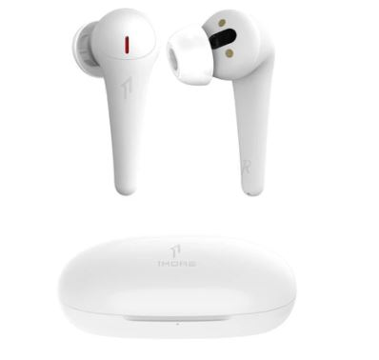
The earbud case contains the earbuds. The earbuds themselves are of a different design than those I have tested before. Each earbud itself has an extension that hangs down from the ear, providing a microphone and a bit more stability than those earbuds that don't have this feature.

The case has a connection for the charging cable and has a small LED that indicates the status of the battery in the charging case. The buds themselves have a charge indicator at the tip end of the hanging lobe, which turns blue when that bud is fully charged and is red otherwise. The back of the case has a USB- C charging port.

The earbuds fit in my ears quite comfortably and are a bit more stable because of the extended hanging portion. I've had trouble in the past with other earbuds falling out of my ear when I lean over or move my head side to side.

The earbuds charge automatically when you put them in their place inside the case, and when the case lid is closed, they will be available fully charged for the next time. Likewise, as soon as you take an earbud out of the case, it is powered on and available for use immediately.

This product is Bluetooth enabled, and the first step in using them, as with any other earbuds, is to pair them with a device. Pairing usually works perfectly, but I had difficulty initiating pairing: after some investigation, a small piece of plastic was inserted in the earbud to prevent the battery from wearing down before the purchaser uses it. Once these pieces of plastic were removed, pairing went uneventfully.

Once the earbuds are inserted in your ear, you can control volume and playback, as needed, by tapping on the hanging lobes. However, it requires a double tap to play or pause.

The earbuds will handle accessing phone calls, as most earbuds do, again requiring a double tap to access the call or end it. One nice feature is that as you are playing a song if you remove the ear Bud from your ear, playback will stop but continue playing when the earbud is reinserted. Finally, a triple tap accesses your cell phone assistant, e.g., Siri.

The product includes active noise canceling, as many similar products do today. There are three levels of noise-canceling effect available in the product. You pinch the lobe to cycle through the three levels.

The product also includes a complimentary "1MORE MUSIC" app, which can be used to verify the charge status of the earbuds and the case and provide certain music services.

The company provides a one-year limited warranty.

"ComfoBuds Pro" True Wireless Headphones by 1More

Price $95

https://usa.1more.com/collections/headphones/products/comfobuds-pro-true-wireless-headphones

